
Viewed by:
Philippe POHER
Tel.: +33 (0)2 99 27 92 92
E-mail: philippe.poher@iwedia.com

Written by:
Philippe POHER
Tel.: +33 (0)2 99 27 92 92
E-mail: philippe.poher@iwedia.com
IWEDIA

TDAL_PVR Technical Specifications

V2.0

Approved by:
Thierry GARNIER
Tel.: +33 (0)2 99 27 92 92
E-mail: thierry.garnier@iwedia.com
SUMMARY
1 Reference documents 5
2 Documentation History 6
3 Introduction 7
4 Module Overview and Architecture 8
4.1 Definitions, Acronyms and Abbreviations 8
4.2 General Description 9
4.2.1 Interactions with other TDAL modules 10
4.3 Architecture 10
4.4 TDAL_PVR API Description 11
4.4.1 Generic Interface 11
4.4.2 Recording Interface 11
4.4.3 Timeshift Interface 12
4.4.4 Playback Interface 12
5 TDAL_PVR API Specification 13
5.1 Type Specifications 13
5.1.1 Generic 13
5.2 TDAL_PVR API Usage 14
5.2.1 Event reception processing 14
5.2.2 Recording 15
5.2.3 Playback 16
5.2.4 Timeshift 17
5.3 TDAL_PVR Macro/Define/Enum/Typedef/Structure Definitions 18
5.3.1 Define Definitions 18
5.3.1.1 kTDAL_PVR_MAX_SUBTITLEINFO_NUM 18
5.3.1.2 kTDAL_PVR_MAX_AUDIOINFO_NUM 18
5.3.2 Enum Definitions 19
5.3.2.1 tTDAL_PVR_Error 19
5.3.2.2 tTDAL_PVR_Encr 19
5.3.2.3 tTDAL_PVR_Event 19
5.3.2.4 tTDAL_PVR_Speed 20
5.3.3 Typedef Definitions 20
5.3.3.1 tTDAL_PVR_Handle 20
5.3.3.2 tTDAL_PVR_Callback 21
5.3.4 Structure Definitions 22
5.3.4.1 tTDAL_PVR_AudioInfo 22
5.3.4.2 tTDAL_PVR_SubsInfo 22
5.3.4.3 tTDAL_PVR_BasicProgInfo 23
5.3.4.4 tTDAL_PVR_ComplexProgInfo 23
5.4 TDAL_PVR API Functions 24
5.4.1 Generic Interface API 24
5.4.1.1 TDAL_PVR_Init(-) 24
5.4.1.2 TDAL_PVR_Term(-) 25
5.4.1.3 TDAL_PVR_Open(-) 26
5.4.1.4 TDAL_PVR_Close(-) 27
5.4.1.5 TDAL_PVR_RegisterCallback (-) 28
5.4.1.5 TDAL_PVR_SetProgramInfo(-) 29
5.4.1.6 TDAL_PVR_GetProgramInfo(-) 30
5.4.1.7 TDAL_PVR_SetFreeSpaceThreshold(-) 31
5.4.1.8 TDAL_PVR_GetFreeSpaceThreshold(-) 32
5.4.2 Recording Interface API 33
5.4.2.1 TDAL_PVR_Record_Start(-) 33
5.4.2.2 TDAL_PVR_Record_Stop(-) 34
5.4.2.3 TDAL_PVR_Record_Pause(-) 35
5.4.2.4 TDAL_PVR_Record_Resume(-) 36
5.4.2.5 TDAL_PVR_IsRecording(-) 37
5.4.3 Timeshift Interface API 38
5.4.3.1 TDAL_PVR_Timeshift_RecordStart(-) 38
5.4.3.2 TDAL_PVR_Timeshift_RecordStop(-) 39
5.4.3.3 TDAL_PVR_Timeshift_PlaybackStart(-) 40
5.4.3.4 TDAL_PVR_Timeshift_PlaybackStop(-) 41
5.4.4 Playback Interface API 42
5.4.4.1 TDAL_PVR_PlaybackStart(-) 42
5.4.4.2 TDAL_PVR_PlaybackStop(-) 43
5.4.4.3 TDAL_PVR_PlaybackPause(-) 44
5.4.4.4 TDAL_PVR_PlaybackResume(-) 45
5.4.4.5 TDAL_PVR_PlaybackFastForward(-) 46
5.4.4.6 TDAL_PVR_PlaybackFastBackward(-) 47
5.4.4.7 TDAL_PVR_PlaybackGetSpeed(-) 48
5.4.4.8 TDAL_PVR_PlaybackJumpToTime(-) 49
6 TDAL_PVR External Dependencies 50
6.1.1.1 tTDAL_PVR_Callback 50

Reference documents
The following documents were used to write this specification:

Document | Version | Title

Documentation History

History
Vers. | Date | Nature
2.0 | 17/01/2008 | PPO: First version of TDAL_KBD

Introduction
The purpose of this document is to specify the interface and to describe the internal design of the Thin Driver Adaptation Layer for Personal Video Recording [TDAL_PVR]. The aim of this module is to provide a complete interface between middlewares and PVR functionality of low level driver of a set-top-box.

Module Overview and Architecture

Definitions, Acronyms and Abbreviations
CHAL | Comedia hardware Adaptation Layer, composed of TDALs driver, TKEL and TBOX module
TDAL | Thin Driver Adaptation Layer
TKEL | Thin Kernel Encapsulation Layer
TBOX | Tool Box

General Description
The main job of the TDAL_PVR is to record content, provide timeshift functionality and play recorded content.

Module TDAL_PVR provides API for controlling content recording, timeshift functionality and playback of recorded content.

Interactions with other TDAL modules

Architecture
The figure below shows the relation between the client module and the low level drivers:
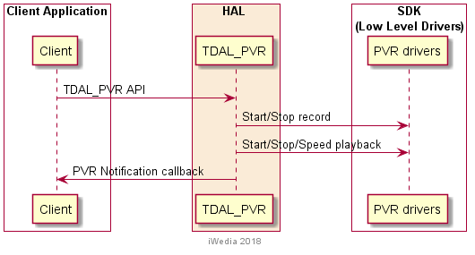

TDAL_PVR API Description

Generic Interface
The generic interface allows clients to control the TDAL_PVR module.
This interface is used with the following functions:
- TDAL_PVR_Init (-) in order to initialize the TDAL_PVR module.
- TDAL_PVR_Term (-) in order to terminate the TDAL_PVR module.
- TDAL_PVR_Open (-) in order to register one client to TDAL_PVR
- TDAL_PVR_Close (-) in order to get data on the instance.
- TDAL_PVR_RegisterCallback(-) in order to register client callback function for event notifications from TDAL_PVR instance.
- TDAL_PVR_SetProgramInfo (-) in order to set program information for recording, timeshift and playback on the instance.
- TDAL_PVR_GetProgramInfo (-) in order to get program information for recording, timeshift and playback on the instance.
- TDAL_PVR_SetFreeSpaceThreshold (-) in order to set space limit for recording data on the storage device.
- TDAL_PVR_GetFreeSpaceThreshold in order to get space limit for recording data on the storage device.

Recording Interface
The generic interface allows clients to control recording for the TDAL_PVR module. This interface is used with the following functions:
- TDAL_PVR_Record_Start(-) in order to start recording on the instace.
- TDAL_PVR_Record_Stop(-) in order to stop recording on the instance.
- TDAL_PVR_Record_Pause(-) in order to pause recording on the instance.
- TDAL_PVR_Record_Resume(-) in order to resume paused recording on the instance.
- TDAL_PVR_IsRecording(-) in order to get information if recording is in progress on the instance.

Timeshift Interface
The generic interface allows clients to control timeshift for the TDAL_PVR module. This interface is used with the following functions:

- TDAL_PVR_Timeshift_RecordStart(-) in order to start timeshift recording on the instace.
- TDAL_PVR_Timeshift_RecordStop(-) in order to stop timeshift recording on the instance.
- TDAL_PVR_Timeshift_PlaybackStart(-) in order to start playback of timeshifted recording on the instance.
- TDAL_PVR_Timeshift_PlaybackStop(-) in order to stop playback of timeshifted recording on the instance.

Playback Interface
The generic interface allows clients to control playback for the TDAL_PVR module. This interface is used with the following functions:
- TDAL_PVR_PlaybackStart(-) in order to start playback on the instace.
- TDAL_PVR_PlaybackStop(-) in order to stop playback on the instance.
- TDAL_PVR_PlaybackPause(-) in order to pause playback on the instance.
- TDAL_PVR_PlaybackResume(-) in order to resume paused playback on the instance.
- TDAL_PVR_PlaybackFastForward(-) in order to start fastforwarding playback on the instace.
- TDAL_PVR_PlaybackFastBackward(-) in order to start fastbackwarding playback on the instace.
- TDAL_PVR_PlaybackGetSpeed(-) in order to get playback speed on the instance.
- TDAL_PVR_PlaybackJumpToTime(-) in order to jump to specific point on playback on the instance.

TDAL_PVR API Specification

Type Specifications

Generic
tTDAL_PVR_Error is the error code return by TDAL_PVR function.
tTDAL_PVR_Handle is handle for TDAL_PVR instance.
tTDAL_PVR_Encr is an enumeration for encryption of recording/playbacking content.
tTDAL_PVR_Event is an enumeration of different events signalled to client about state of TDAL_PVR instance.
tTDAL_PVR_Speed is enumeration of different speeds for trick modes.
tTDAL_PVR_AudioInfo is structure holding information about audio tracks.
tTDAL_PVR_SubsInfo is structure holding information about subtitle tracks.
tTDAL_PVR_BasicProgInfo is structure containing information for setting up recording, timeshift or playback.
tTDAL_PVR_ComplexProgInfo is structure containing information about recording, timeshift or playback.
tTDAL_PVR_Callback is the callback to implement by the client to receive event notification.

TDAL_PVR API Usage
    - Recording
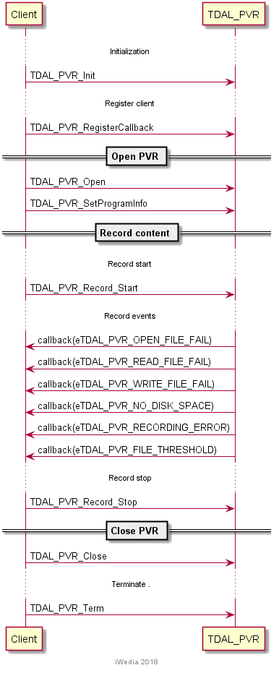

    - Playback
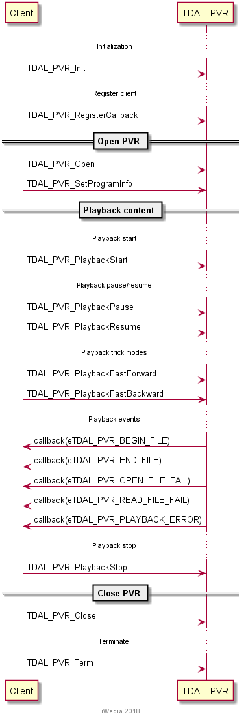

    - Timeshift
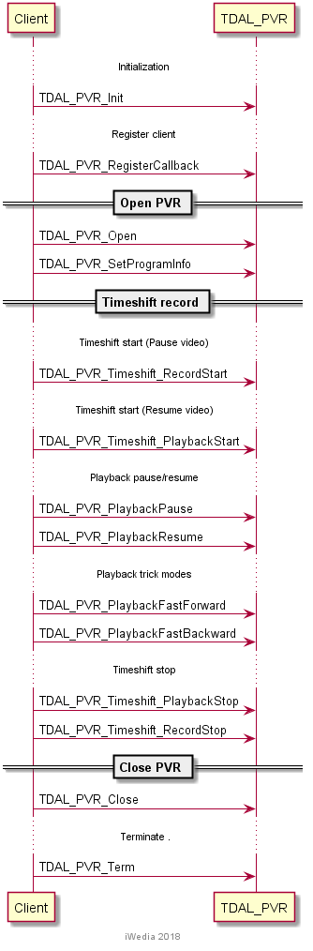

TDAL_PVR Macro/Define/Enum/Typedef/Structure Definitions

Define Definitions

kTDAL_PVR_MAX_SUBTITLEINFO_NUM
This constant is used to define the maximum number of subtitle tracks.
#define kTDAL_PVR_MAX_SUBTITLEINFO_NUM 12

kTDAL_PVR_MAX_AUDIOINFO_NUM
This constant is used to define the maximum number of audio tracks.
#define kTDAL_PVR_MAX_AUDIOINFO_NUM 16

Enum Definitions

tTDAL_PVR_Error
An enumeration of the different possible error values handled by TDAL_PVR.
typedef enum TDAL_PVR_Error_e {
eTDAL_PVR_NO_ERROR = 0, /* no error */
eTDAL_PVR_ERROR_NOT_INIT, /* driver is not initialised */
eTDAL_PVR_ERROR_BAD_ARG, /* wrong argument value */
eTDAL_PVR_ERROR_IN_DRIVER, /* error in the driver */
eTDAL_PVR_ERROR_NOT_DONE /* command not done */
} tTDAL_PVR_Error;

tTDAL_PVR_Encr
An enumeration for encryption of recording/playbacking content.

typedef enum TDAL_PVR_Encr_e {
eTDAL_PVR_ENCR_NONE,
eTDAL_PVR_ENCR_DEFAULT,
eTDAL_PVR_ENCR_USER,
eTDAL_PVR_ENCR_CIPLUS,
eTDAL_PVR_ENCR_SMARTCARD
} tTDAL_PVR_Encr;

tTDAL_PVR_Event
An enumeration of different events signalled to client about state of TDAL_PVR instance.
typedef enum tTDAL_PVR_Event_e {
eTDAL_PVR_END_FILE = 0, /* playback reached the end of file */
eTDAL_PVR_BEGIN_FILE, /* playback reached the end of file */
eTDAL_PVR_OPEN_FILE_FAIL, /* open file failed */
eTDAL_PVR_READ_FILE_FAIL, /* read file failed */
eTDAL_PVR_WRITE_FILE_FAIL, /* write file failed */
eTDAL_PVR_NO_DISK_SPACE, /* no disk space for recording */
eTDAL_PVR_RECORDING_ERROR, /* something went wrong with recording */
eTDAL_PVR_PLAYBACK_ERROR, /* something went wrong with playback */
eTDAL_PVR_FILE_THRESHOLD /* threshold for file size reached */
} tTDAL_PVR_Event;

tTDAL_PVR_Speed
An enumeration of different speeds for trick modes.
typedef enum tTDAL_PVR_Speed_e {
eTDAL_PVR_SPEED_64X_BACKWARD ,
eTDAL_PVR_SPEED_32X_BACKWARD ,
eTDAL_PVR_SPEED_16X_BACKWARD ,
eTDAL_PVR_SPEED_8X_BACKWARD ,
eTDAL_PVR_SPEED_4X_BACKWARD ,
eTDAL_PVR_SPEED_2X_BACKWARD ,
eTDAL_PVR_SPEED_1X_BACKWARD ,
eTDAL_PVR_SPEED_0X5_BACKWARD ,
eTDAL_PVR_SPEED_0X25_BACKWARD ,
eTDAL_PVR_SPEED_0X ,
eTDAL_PVR_SPEED_FREEZE ,
eTDAL_PVR_SPEED_0X25_FORWARD ,
eTDAL_PVR_SPEED_0X5_FORWARD ,
eTDAL_PVR_SPEED_1X_FORWARD ,
eTDAL_PVR_SPEED_2X_FORWARD ,
eTDAL_PVR_SPEED_4X_FORWARD ,
eTDAL_PVR_SPEED_8X_FORWARD ,
eTDAL_PVR_SPEED_16X_FORWARD ,
eTDAL_PVR_SPEED_32X_FORWARD ,
eTDAL_PVR_SPEED_64X_FORWARD
} tTDAL_PVR_Speed;

Typedef Definitions

tTDAL_PVR_Handle
This type is handle for TDAL_PVR instance.
typedef uint32_t tTDAL_PVR_Handle;

tTDAL_PVR_Callback
This typedef defines the callback to implement by the client to receive TDAL_PVR event notification.
typedef void (*tTDAL_PVR_Callback)(
tTDAL_PVR_Event pvrEvent,
tTDAL_PVR_Handle pvrHandle
);

Parameters:
Parameter | Type | Dir | Description
pvrEvent | tTDAL_PVR_Event | In | PVR event to be sent
pvrHandle | tTDAL_PVR_Handle | In | Handle for TDAL_PVR instance

Structure Definitions

tTDAL_PVR_AudioInfo
Structure holding information about audio tracks.
typedef struct tTDAL_PVR_AudioInfo_t
{
uint8_t isoLangInfo[3]; /* Language info */
// uint8_t isoAudMode; /* 0x00: Stereo, 0x01: Mono right, 0x02: Mono left */
// uint8_t isoAudType; /* 0x00:Undefined,
// 0x01:Clean effects,
// 0x02: Hearing impaired,
// 0x03: Visual impaired commentary,
// 0x04~0xFF: Reserved */
uint8_t u8ISOIsValid; /* */
uint16_t u16AudioPID; /* Audio PID*/
uint8_t u8AudioType; /* TDAL AUDIO type */

} tTDAL_PVR_AudioInfo;

tTDAL_PVR_SubsInfo
Structure holding information about subtitle tracks.
typedef struct tTDAL_PVR_SubtitleInfo_t
{
uint8_t u8ComponentTag;
uint16_t u16Sub_Pid;
uint8_t u8lanuage_code[3];
uint8_t u8subtitling_type; // EN_TTX_TYPE
uint16_t u16composition_page_id;
uint16_t u16ancillary_page_id;

} tTDAL_PVR_SubsInfo;

tTDAL_PVR_BasicProgInfo
Structure containing information for setting up recording, timeshift or playback.
typedef struct tTDAL_PVR_BasicProgInfo_t
{
uint32_t u32PCRPid;
uint32_t u32VideoPid;
uint32_t u32AudioPid;
uint32_t u32VCodec;
uint32_t u32ACodec;
uint32_t u32PmtPid;
uint32_t u32LCN;
uint8_t nAudioInfoCount;
tTDAL_PVR_AudioInfo pAudioInfo[kTDAL_PVR_MAX_AUDIOINFO_NUM];
uint8_t nSubsInfoCount;
tTDAL_PVR_SubsInfo pSubsInfo[kTDAL_PVR_MAX_SUBTITLEINFO_NUM];
char* fileName;
uint32_t fileThreshold;
uint8_t filesCount;
tTDAL_PVR_Encr eEncryptionType;
bool bIsEncrypted;
uint8_t u8CryptKey[4];
} tTDAL_PVR_BasicProgInfo;

tTDAL_PVR_ComplexProgInfo
Structure containing information about recording, timeshift or playback.
typedef struct tTDAL_PVR_ComplexProgInfo_t
{
tTDAL_PVR_BasicProgInfo stPVRBasicProgInfo;
uint32_t u32duration;
uint32_t u32StartTime;
uint64_t u64FileLength;
uint8_t u8Age;
bool bLocked;
uint32_t u32LastPlayPositionInSec;
} tTDAL_PVR_ComplexProgInfo;

TDAL_PVR API Functions

Generic Interface API

TDAL_PVR_Init(-)
Prototype:
tTDAL_PVR_Error TDAL_PVR_Init(void);
Description:
This function initialises the TDAL_PVR module.
Return value:
It returns eTDAL_PVR_NO_ERROR if initialization succeed.
It could eTDAL_PVR_ERROR_NOT_DONE otherwise.
Parameters:
None.
Comments:
This function must be called before any other functions of the TDAL_PVR API.
See Also:
TDAL_PVR_Term(-).

TDAL_PVR_Term(-)
Prototype:
tTDAL_PVR_Error TDAL_PVR_Term(void);
Description:
This function terminates the TDAL_PVR module.
Return value:
It returns eTDAL_PVR_NO_ERROR if termination succeed.
Parameters:
None.
Comments:
Any function of TDAL_PVR API should not be called after TDAL_PVR_Term(-) call.
See Also:
TDAL_PVR_Init(-).

TDAL_PVR_Open (-)
Prototype:
tTDAL_PVR_Error TDAL_PVR_Open(
tTDAL_PVR_Handle *pvrHandle,
bool bIsTimeshift,
const char* pPath
);
Description:
This function allows to register one client to TDAL_PVR.

Return value:
It returns the eTDAL_PVR_NO_ERROR if register succeeds.
Parameters:
Parameter | Type | Dir | Description
pvrHandle | tTDAL_PVR_Handle* | Out | Handle for TDAL_PVR instance
bIsTimeshift | bool | In | Is timeshift on
pPath | char* | In | File path for recording if timeshift is on
Comments:
This function can be called at any time the TDAL_PVR has been initialised with TDAL_PVR_Init(-) but not after the termination with TDAL_PVR_Terminate(-).
See Also:

TDAL_PVR_Close (-)
Prototype:
tTDAL_PVR_Error TDAL_PVR_Close(
tTDAL_PVR_Handle pvrHandle
);
Description:
This function allows client to get data on the instance.
Return value:
It returns eTDAL_PVR_NO_ERROR if termination succeed.

Parameters:
Parameter | Type | Dir | Description
pvrHandle | tTDAL_PVR_Handle | In | Handle for TDAL_PVR instance
Comments:
This function can be called at any time the TDAL_PVR has been initialised with TDAL_PVR_Init(-) but not after the termination with TDAL_PVR_Term(-).
See Also:

TDAL_PVR_RegisterCallback (-)
Prototype:
tTDAL_PVR_Error TDAL_PVR_RegisterCallback(
tTDAL_PVR_Callback PVR_CB
);
Description:
- This function allows to register client callback function for event notifications from TDAL_PVR instance.

Return value:
It returns eTDAL_PVR_NO_ERROR if it succeed.

Parameters:
Parameter | Type | Dir | Description
PVR_CB | tTDAL_PVR_Callback | In | Client callback function
Comments:
This function can be called at any time the TDAL_PVR has been initialised with TDAL_PVR_Init(-) but not after the termination with TDAL_PVR_Term(-).
See Also:

TDAL_PVR_SetProgramInfo (-)
Prototype:
tTDAL_PVR_Error TDAL_PVR_SetProgramInfo(
tTDAL_PVR_Handle pvrHandle,
tTDAL_PVR_BasicProgInfo *pBasicProgInfo
);

Description:
- This function is called in order to set program information for recording, timeshift and playback on the instance.

Return value:
It returns eTDAL_PVR_NO_ERROR if it succeed.

Parameters:
Parameter | Type | Dir | Description
pvrHandle | tTDAL_PVR_Handle | In | Handle for TDAL_PVR instance
pBasicProgInfo | tTDAL_PVR_BasicProgInfo* | In | Pointer to tTDAL_PVR_BasicProgInfo structure

Comments:

See Also:

TDAL_PVR_GetProgramInfo (-)
Prototype:
tTDAL_PVR_Error TDAL_PVR_GetProgramInfo(
tTDAL_PVR_Handle pvrHandle,
tTDAL_PVR_ComplexProgInfo *pPVRComplexInfo
);

Description:
- This function is called in order to get program information for recording, timeshift and playback on the instance.

Return value:
It returns eTDAL_PVR_NO_ERROR if it succeed.

Parameters:
Parameter | Type | Dir | Description
pvrHandle | tTDAL_PVR_Handle | In | Handle for TDAL_PVR instance
pPVRComplexInfo | tTDAL_PVR_ComplexProgInfo* | Out | Pointer to tTDAL_PVR_ComplexProgInfo structure

Comments:

See Also:

TDAL_PVR_SetFreeSpaceThreshold (-)
Prototype:
void TDAL_PVR_SetFreeSpaceThreshold(
uint8_t percent
);

Description:
- This function is called in order to set space limit for recording data on the storage device.

Return value:
None.

Parameters:
Parameter | Type | Dir | Description
percent | uint8_t | In | Percentage of space to keep free

Comments:

See Also:

TDAL_PVR_GetFreeSpaceThreshold (-)
Prototype:
uint8_t TDAL_PVR_GetFreeSpaceThreshold();

Description:
- This function is called in order to get space limit for recording data on the storage device.

Return value:
It returns free space threshold.

Parameters:
Parameter | Type | Dir | Description

Comments:

See Also:

Recording Interface API

TDAL_PVR_Record_Start (-)
Prototype:
tTDAL_PVR_Error TDAL_PVR_Record_Start(
tTDAL_PVR_Handle pvrHandle
);

Description:
- This function is called in order to start recording on the instace.

Return value:
It returns eTDAL_PVR_NO_ERROR if it succeed.

Parameters:
Parameter | Type | Dir | Description
pvrHandle | tTDAL_PVR_Handle | In | Handle for TDAL_PVR instance

Comments:

See Also:

TDAL_PVR_Record_Stop (-)
Prototype:
tTDAL_PVR_Error TDAL_PVR_Record_Stop(
tTDAL_PVR_Handle pvrHandle
);

Description:
- This function is called in order to stop recording on the instace.

Return value:
It returns eTDAL_PVR_NO_ERROR if it succeed.

Parameters:
Parameter | Type | Dir | Description
pvrHandle | tTDAL_PVR_Handle | In | Handle for TDAL_PVR instance

Comments:

See Also:

TDAL_PVR_Record_Pause (-)
Prototype:
tTDAL_PVR_Error TDAL_PVR_Record_Pause(
tTDAL_PVR_Handle pvrHandle
);

Description:
- This function is called in order to pause recording on the instace.

Return value:
It returns eTDAL_PVR_NO_ERROR if it succeed.

Parameters:
Parameter | Type | Dir | Description
pvrHandle | tTDAL_PVR_Handle | In | Handle for TDAL_PVR instance

Comments:

See Also:

TDAL_PVR_Record_Resume (-)
Prototype:
tTDAL_PVR_Error TDAL_PVR_Record_Resume(
tTDAL_PVR_Handle pvrHandle
);

Description:
- This function is called in order to resume paused recording on the instance.

Return value:
It returns eTDAL_PVR_NO_ERROR if it succeed.

Parameters:
Parameter | Type | Dir | Description
pvrHandle | tTDAL_PVR_Handle | In | Handle for TDAL_PVR instance

Comments:

See Also:

TDAL_PVR_IsRecording (-)
Prototype:
bool TDAL_PVR_IsRecording(
tTDAL_PVR_Handle pvrHandle
);

Description:
- This function is called in order to get information if recording is in progress on the instance.

Return value:
It returns TRUE if recording is in progress, FALSE otherwise.

Parameters:
Parameter | Type | Dir | Description
pvrHandle | tTDAL_PVR_Handle | In | Handle for TDAL_PVR instance

Comments:

See Also:

Timeshift Interface API

TDAL_PVR_Timeshift_RecordStart (-)
Prototype:
tTDAL_PVR_Error TDAL_PVR_Timeshift_RecordStart(
tTDAL_PVR_Handle pvrHandle
);

Description:
- This function is called in order to start timeshift recording on the instace.

Return value:
It returns eTDAL_PVR_NO_ERROR if it succeed.

Parameters:
Parameter | Type | Dir | Description
pvrHandle | tTDAL_PVR_Handle | In | Handle for TDAL_PVR instance

Comments:

See Also:

TDAL_PVR_Timeshift_RecordStop (-)
Prototype:
tTDAL_PVR_Error TDAL_PVR_Timeshift_RecordStop(
tTDAL_PVR_Handle pvrHandle
);

Description:
- This function is called in order to stop timeshift recording on the instace.

Return value:
It returns eTDAL_PVR_NO_ERROR if it succeed.

Parameters:
Parameter | Type | Dir | Description
pvrHandle | tTDAL_PVR_Handle | In | Handle for TDAL_PVR instance

Comments:

See Also:

TDAL_PVR_Timeshift_PlaybackStart (-)
Prototype:
tTDAL_PVR_Error TDAL_PVR_Timeshift_PlaybackStart(
tTDAL_PVR_Handle pvrHandle,
uint32_t u32PlaybackTimeInSec
);

Description:
- This function is called in order to start playback of timeshifted recording on the instance.

Return value:
It returns eTDAL_PVR_NO_ERROR if it succeed.

Parameters:
Parameter | Type | Dir | Description
pvrHandle | tTDAL_PVR_Handle | In | Handle for TDAL_PVR instance
u32PlaybackTimeInSec | uint32_t | In | Playback start point

Comments:

See Also:

TDAL_PVR_Timeshift_PlaybackStop (-)
Prototype:
tTDAL_PVR_Error TDAL_PVR_Timeshift_PlaybackStop(
tTDAL_PVR_Handle pvrHandle
);

Description:
- This function is called in order to stop playback of timeshifted recording on the instance.

Return value:
It returns eTDAL_PVR_NO_ERROR if it succeed.

Parameters:
Parameter | Type | Dir | Description
pvrHandle | tTDAL_PVR_Handle | In | Handle for TDAL_PVR instance

Comments:

See Also:

Playback Interface API

TDAL_PVR_PlaybackStart (-)
Prototype:
tTDAL_PVR_Error TDAL_PVR_PlaybackStart(
tTDAL_PVR_Handle pvrHandle,
uint32_t u32PlaybackTimeInSec
);

Description:
- This function is called in order to start playback on the instace.

Return value:
It returns eTDAL_PVR_NO_ERROR if it succeed.

Parameters:
Parameter | Type | Dir | Description
pvrHandle | tTDAL_PVR_Handle | In | Handle for TDAL_PVR instance
u32PlaybackTimeInSec | uint32_t | In | Playback start point

Comments:

See Also:

TDAL_PVR_PlaybackStop (-)
Prototype:
tTDAL_PVR_Error TDAL_PVR_PlaybackStop(
tTDAL_PVR_Handle pvrHandle
);

Description:
- This function is called in order to stop playback on the instace.

Return value:
It returns eTDAL_PVR_NO_ERROR if it succeed.

Parameters:
Parameter | Type | Dir | Description
pvrHandle | tTDAL_PVR_Handle | In | Handle for TDAL_PVR instance

Comments:

See Also:

TDAL_PVR_PlaybackPause (-)
Prototype:
tTDAL_PVR_Error TDAL_PVR_PlaybackPause(
tTDAL_PVR_Handle pvrHandle
);

Description:
- This function is called in order to pause playback on the instace.

Return value:
It returns eTDAL_PVR_NO_ERROR if it succeed.

Parameters:
Parameter | Type | Dir | Description
pvrHandle | tTDAL_PVR_Handle | In | Handle for TDAL_PVR instance

Comments:

See Also:

TDAL_PVR_PlaybackResume (-)
Prototype:
tTDAL_PVR_Error TDAL_PVR_PlaybackResume(
tTDAL_PVR_Handle pvrHandle
);

Description:
- This function is called in order to resume paused playback on the instace.

Return value:
It returns eTDAL_PVR_NO_ERROR if it succeed.

Parameters:
Parameter | Type | Dir | Description
pvrHandle | tTDAL_PVR_Handle | In | Handle for TDAL_PVR instance

Comments:

See Also:

TDAL_PVR_PlaybackFastForward (-)
Prototype:
tTDAL_PVR_Error TDAL_PVR_PlaybackFastForward(
tTDAL_PVR_Handle pvrHandle,
tTDAL_PVR_Speed enTrick
);

Description:
- This function is called in order to start fastforwarding playback on the instace.

Return value:
It returns eTDAL_PVR_NO_ERROR if it succeed.

Parameters:
Parameter | Type | Dir | Description
pvrHandle | tTDAL_PVR_Handle | In | Handle for TDAL_PVR instance
enTrick | tTDAL_PVR_Speed | In | Fast forwarding speed

Comments:

See Also:

TDAL_PVR_PlaybackFastBackward (-)
Prototype:
tTDAL_PVR_Error TDAL_PVR_PlaybackFastBackward(
tTDAL_PVR_Handle pvrHandle,
tTDAL_PVR_Speed enTrick
);

Description:
- This function is called in order to start fastbackwarding playback on the instace.

Return value:
It returns eTDAL_PVR_NO_ERROR if it succeed.

Parameters:
Parameter | Type | Dir | Description
pvrHandle | tTDAL_PVR_Handle | In | Handle for TDAL_PVR instance
enTrick | tTDAL_PVR_Speed | In | Fast backwarding speed

Comments:

See Also:

TDAL_PVR_PlaybackGetSpeed (-)
Prototype:
tTDAL_PVR_Error TDAL_PVR_PlaybackGetSpeed(
tTDAL_PVR_Handle pvrHandle,
tTDAL_PVR_Speed* pSpeed
);

Description:
- This function is called in order to get playback speed on the instance.

Return value:
It returns eTDAL_PVR_NO_ERROR if it succeed.

Parameters:
Parameter | Type | Dir | Description
pvrHandle | tTDAL_PVR_Handle | In | Handle for TDAL_PVR instance
pSpeed | tTDAL_PVR_Speed* | Out | Pointer to tTDAL_PVR_Speed structure

Comments:

See Also:

TDAL_PVR_PlaybackJumpToTime (-)
Prototype:
tTDAL_PVR_Error TDAL_PVR_PlaybackJumpToTime(
tTDAL_PVR_Handle pvrHandle,
int32_t *u32Hour,
uint32_t *u32Minute,
uint32_t *u32Second
);

Description:
- This function is called in order to jump to specific point on playback on the instance.

Return value:
It returns eTDAL_PVR_NO_ERROR if it succeed.

Parameters:
Parameter | Type | Dir | Description
pvrHandle | tTDAL_PVR_Handle | In | Handle for TDAL_PVR instance
u32Hour | int32_t* | In | Hour
u32Minute | uint32_t* | In | Minute
u32Second | uint32_t* | In | Second

Comments:

See Also:

TDAL_PVR External Dependencies

tTDAL_PVR_Callback
This typedef defines the callback to implement by the client to receive TDAL_PVR event notification.
Prototype:
typedef void (*tTDAL_PVR_Callback)(
tTDAL_PVR_Event pvrEvent,
tTDAL_PVR_Handle pvrHandle
);

Return value:
None.
Parameters:
Parameter | Type | Dir | Description
pvrEvent | tTDAL_PVR_Event | In | PVR event to be sent
pvrHandle | tTDAL_PVR_Handle | In | Handle for TDAL_PVR instance
Comments:
None.
See Also:

